**Output of CLIENT SERVER CONNECTION USING UDP**

**Question:**

Write the program of Sender and Receiver using socket program and implement it using the UDP protocol. The first code should have one client and the second code should have multiple clients chatting together. Establish a connection between the client and the server and make a chatting app. The client and the server will both be able to respond back. The second code will have multiple clients and only the server can see all the messages.

Language Used- Python

Code for Single Client Only

**Output 1(Server side) :**

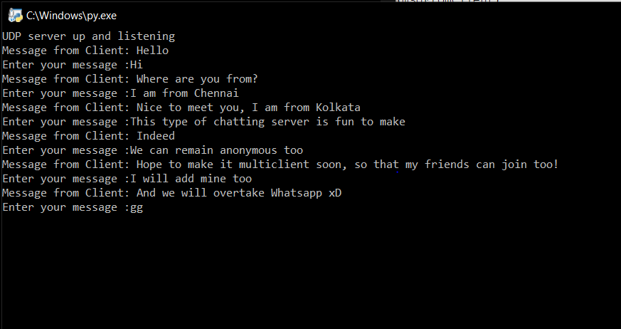

**Output 2(Client side):**

